Exercise 1: Configuring a Basic Spring Application

Aim:
To configure a basic Spring application using Spring Core and XML-based configuration, and demonstrate Dependency Injection.

Implementation:

1.pom.xml (Dependency):
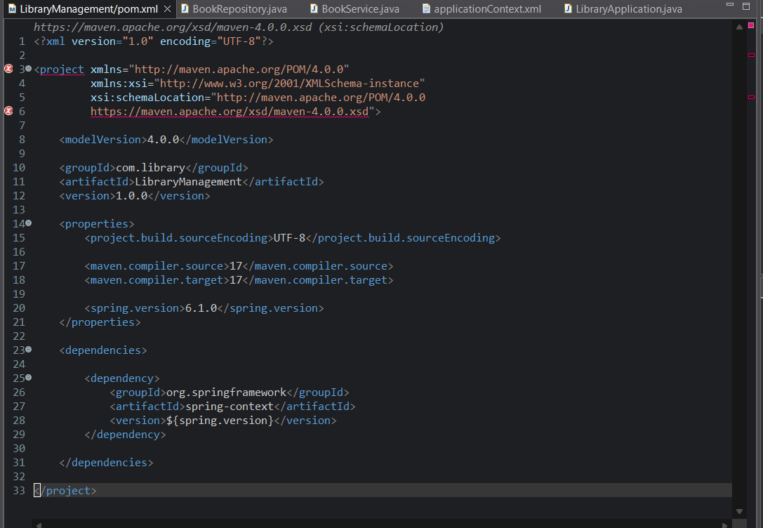

2.BookRepository.java:
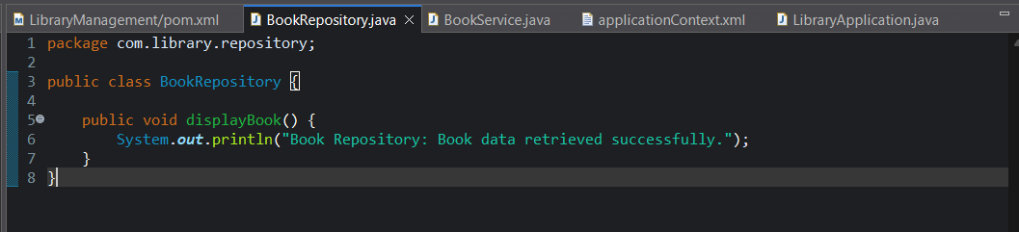

3.BookService.java:
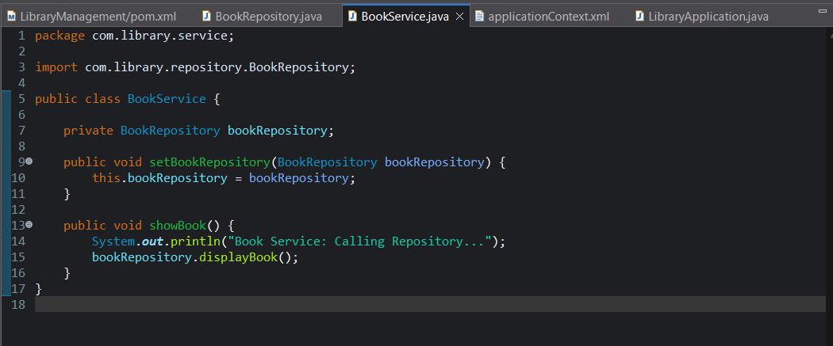

4.applicationContext.xml:
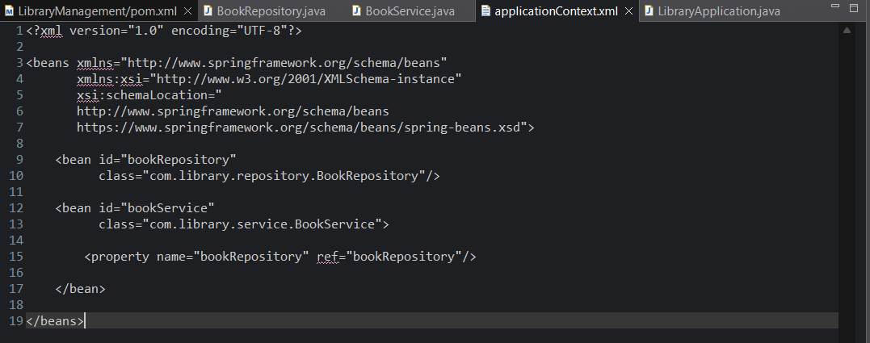

5.LibraryApplication.java:
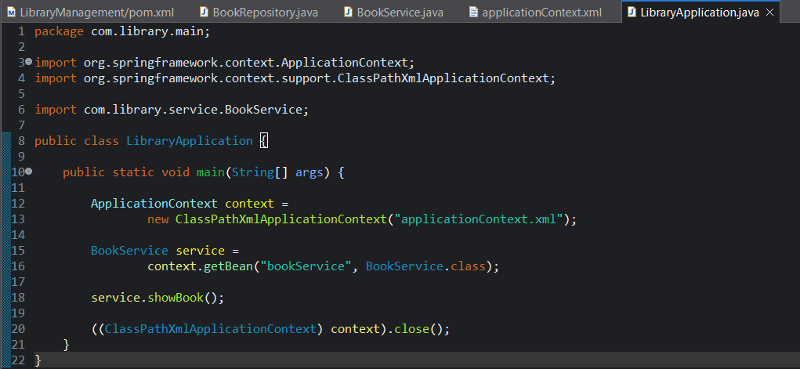

Output:
Book Service: Calling Repository...
Book Repository: Book data retrieved successfully.
